**Project #3: NYC 311 Service Request Analysis**

**Question1:** Import a 311 NYC service request

*Code:*

import numpy as np

import pandas as pd

from matplotlib import pyplot as plt

df = pd.read_csv('/home/labsuser/Datasets/311_Service_Requests_from_2010_to_Present.csv', low_memory=False)

df.head()

**Question2:** Basic data exploratory analysis

* + Explore data
  + Find patterns
  + Display the complaint type and city together

*Code:*

sub_df = pd.concat([df['Complaint Type'], df['City']],axis=1)

#sub_df

sub_df.head()

**Question3:** Find major complaint types

* + Find the top 10 complaint types
  + Plot a bar graph of count vs. complaint types

*#3.1 Code:*

grpd_data = df.groupby('Complaint Type')

complaints_extract = pd.DataFrame(grpd_data['Unique Key'].count()).rename(columns={'Unique Key': 'No_of_Complaints'})

sorted_df = complaints_extract.sort_values('No_of_Complaints', ascending=False)

print('The top 10 complaint types are printed below')

sorted_df.head(10)

*#3.2 Code:*

plt.figure(figsize=(20, 10))

plt.title('Complaint Type Vs. Number of Complaints')

plt.bar(sorted_df.index, sorted_df['No_of_Complaints'])

plt.xticks(range(0, len(sorted_df.index)), sorted_df.index, rotation=90)

for x,y in zip(sorted_df.index, sorted_df['No_of_Complaints']):

plt.annotate(str(y), (x,y),(x,y+1000))

plt.show()

*Screenshot:*

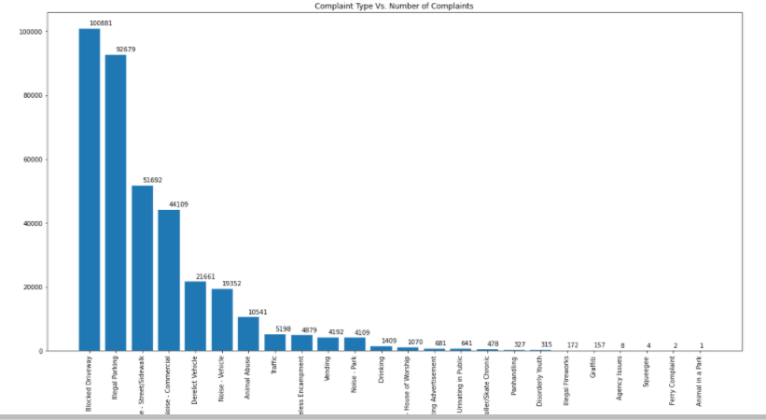

**Question4:** Visualize the complaint types

* + Display the major complaint types and their count

plt.figure(figsize=(20, 10))

plt.title('Complaint Type Vs. Number of Complaints')

plt.plot(sorted_df.index, sorted_df['No_of_Complaints'])

plt.xticks(range(0, len(sorted_df.index)), sorted_df.index, rotation=90)

for x,y in zip(sorted_df.index, sorted_df['No_of_Complaints']):

plt.annotate(str(y), (x,y),(x,y+1000))

plt.show()

*Screenshot:*

